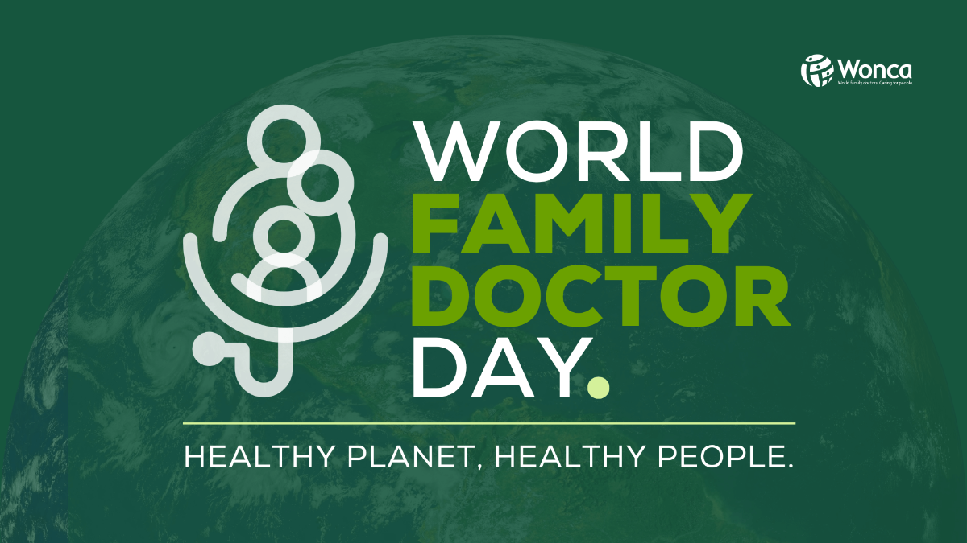

|  |  |
| --- | --- |
| |  | | --- | | **2024 THEME ANNOUNCEMENT**  **WORLD FAMILY DOCTOR DAY: HEALTHY PLANET, HEALTHY PEOPLE:** A key event in the WONCA calendar, celebrated annually on **19 May 2024**, dedicated to underscoring the importance and contributions of family doctors in healthcare systems around the world. This year, we will focus on the urgent need for action against climate change and its impacts on human health.  **THE MESSAGE:** Our patients' health ultimately depends on the environment, both in their immediate vicinity and globally. We are all responsible for looking after our planet. As family doctors on the frontlines, we already see the impacts of climate change on our communities, from rising temperatures, increased extreme weather events, and escalating challenges such as infectious diseases and food insecurity  **TRUSTED SOURCES:** Family doctors are consistently ranked as one of the most trusted sourcesof information, and we have a unique capacity to understand and communicate the shifting landscape of planetary health challenges and the strategies that individuals can take to simultaneously safeguard their health and that of the environment.  **PRIMARY CARE IS PART OF THE SOLUTION:** The healthcare sector accounts for 4.4% of global net emissions. Our campaign will also highlight what we as family doctors can do to make our practices more green and make the case for primary care as a sustainable form of healthcare provision  **CAMPAIGN IDEAS:**We hope to engage both traditional and social media in getting our message across; featuring stories of physicians who have observed the health impacts of climate change firsthand, and those who are already leading on climate action in their communities. We will also produce a video featuring contributions from doctors around the world. [Get in touch](mailto:communications@wonca.net?subject=World%20Family%20Doctor%20Day%202024&body=Hi%20Diarmuid%2C%0A) if you'd like to contribute. | |

|  |  |
| --- | --- |
| |  | | --- | | **COMMUNICATING ABOUT CLIMATE CHANGE AND HEALTH**  **WHO TOOLKIT:**World Health Organization (WHO) in collaboration with partners is launching a new toolkit designed to equip health and care workers with the knowledge and confidence to effectively communicate about climate change and health.   **LAUNCH:**The toolkit will be officially launched on Friday, 22 March, and could be very useful for our World Family Doctor Day campaign! [Register](https://wonca.us20.list-manage.com/track/click?u=ad0a4b638a3d3b914f607b61d&id=9f4b6d1278&e=6c4f1e08bf) for the launch event on Zoom. | |

|  |  |
| --- | --- |
| |  | | --- | | **MONTEGUT GLOBAL SCHOLAR PROGRAM**  **ATTEND A REGIONAL WONCA CONFERENCE:**Named after Alain Montegut, M.D., for his contributions to family medicine globally, and supported by the American Board of Family Medicine Foundation, this award supports family doctors from around the world to attend a regional WONCA conference in 2024.  **APPLY NOW:**Open to family physicians from Africa, Asia Pacific, East Mediterranean, Europe, Iberoamericana, North America, and South Asia regions. The application deadline is Monday, 15 April 2024. [Apply.](https://wonca.us20.list-manage.com/track/click?u=ad0a4b638a3d3b914f607b61d&id=04d673d1b2&e=6c4f1e08bf) | |

|  |  |
| --- | --- |
| |  | | --- | | **UNITING FOR RURAL HEALTH IN CAPE TOWN**  **WONCA RURAL:**WONCA Rural is teaming up with The Network: Towards Unity For Health for a landmark event in the world of rural health. 10 - 13 September 2024.  **UBUNTU 2024:**Read about the keynote speakers, "Conference on the Move", group discounts, and bursaries in Dr. Bruce Chater's preview of the event [here](https://wonca.us20.list-manage.com/track/click?u=ad0a4b638a3d3b914f607b61d&id=b7f12d831c&e=6c4f1e08bf). | |

|  |  |
| --- | --- |
| |  | | --- | | **WONCA CONFERENCES 2024**  **AFRICA:**Abstract submission for the 8th Annual WONCA Africa Conference in Nairobi, Kenya closes on 31 March 2024. [Share your insights.](https://wonca.us20.list-manage.com/track/click?u=ad0a4b638a3d3b914f607b61d&id=d0589e4da3&e=6c4f1e08bf) 5 - 8 June 2024.  **ASIA PACIFIC REGION:**[Early Bird Registration](https://wonca.us20.list-manage.com/track/click?u=ad0a4b638a3d3b914f607b61d&id=bc544b9c68&e=6c4f1e08bf) for Singapore closes on 30 June. Don't delay! 21 - 24 August 2024.  **EUROPE:**[Abstract submission](https://wonca.us20.list-manage.com/track/click?u=ad0a4b638a3d3b914f607b61d&id=042694994e&e=6c4f1e08bf) for the 29th WONCA Europe Conference in Dublin, Ireland closes on 30 March 2024. [Registration](https://wonca.us20.list-manage.com/track/click?u=ad0a4b638a3d3b914f607b61d&id=fd6dc805c0&e=6c4f1e08bf) is also now open. 25 - 28 September 2024.  **RURAL WONCA - UBUNTU 2024:**Early Bird Registration & [Abstract Submissions](https://wonca.us20.list-manage.com/track/click?u=ad0a4b638a3d3b914f607b61d&id=83ea88e86a&e=6c4f1e08bf) close on 31 March 2024. Read Dr Bruce Chater's preview of Ubuntu 2024 [here](https://wonca.us20.list-manage.com/track/click?u=ad0a4b638a3d3b914f607b61d&id=daf5ba1754&e=6c4f1e08bf).  **SOUTH ASIA REGION:**The early bird deadline has been extended by two weeks until 30 March. [Save on registration](https://wonca.us20.list-manage.com/track/click?u=ad0a4b638a3d3b914f607b61d&id=ad3747230c&e=6c4f1e08bf) for Colombo, Sri Lanka. 3 - 5 May 2024. | |

|  |  |
| --- | --- |
| |  | | --- | | Did you miss the March edition of WONCA News? Download the PDF [here](https://wonca.us20.list-manage.com/track/click?u=ad0a4b638a3d3b914f607b61d&id=08c8ec3b1c&e=6c4f1e08bf).  All the best, Diarmuid Hayes WONCA Communications Officer [communications@wonca.net](mailto:communications@wonca.net) | |

|  |  |
| --- | --- |
| |  | | --- | | *You are receiving this message because you are part of the WONCA Community. We use your data according to our*[*Privacy Statement*](https://wonca.us20.list-manage.com/track/click?u=ad0a4b638a3d3b914f607b61d&id=4597f0f4ac&e=6c4f1e08bf)*.* | |